**DA ASSIGNMENT-1**

**Name:** N.Rajitha

**Roll No:** 22BFA05307

**Course:** Data Analytics with Tableau

1.Bar Chart

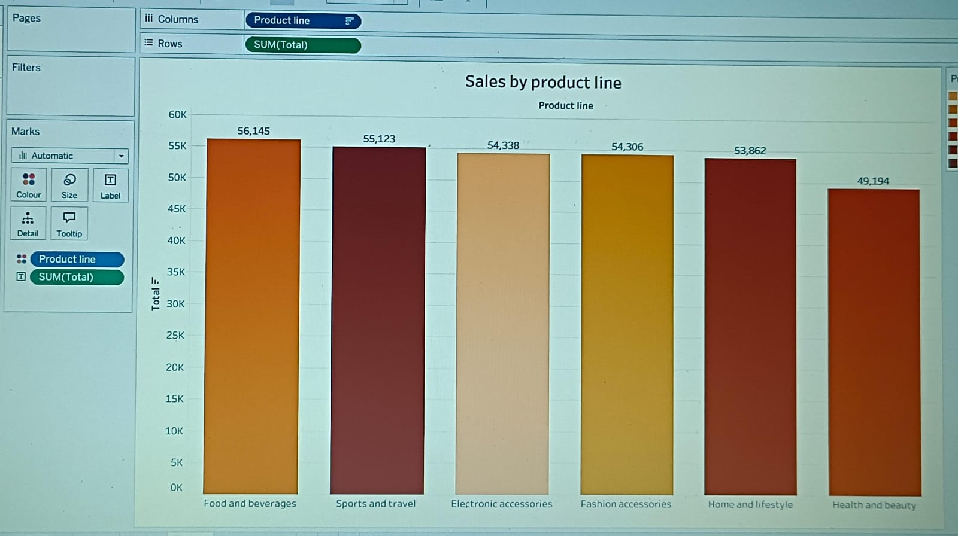

2. Pie Chart

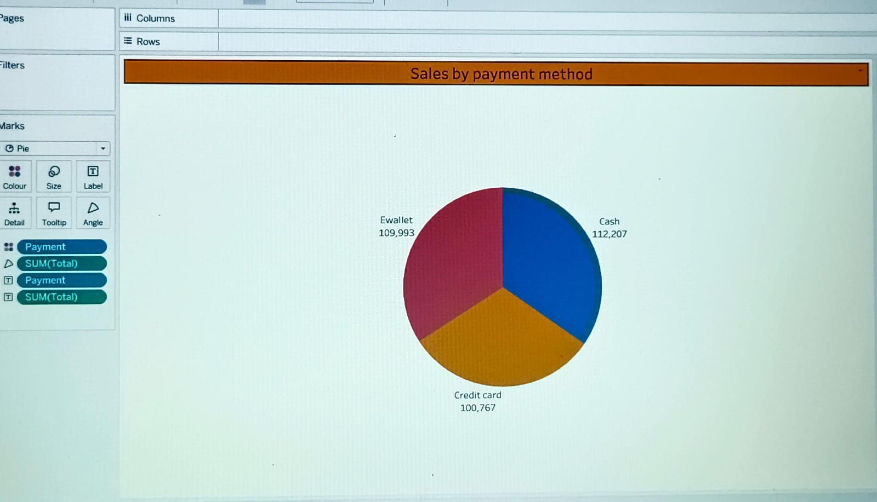

3. Stacked bar chart

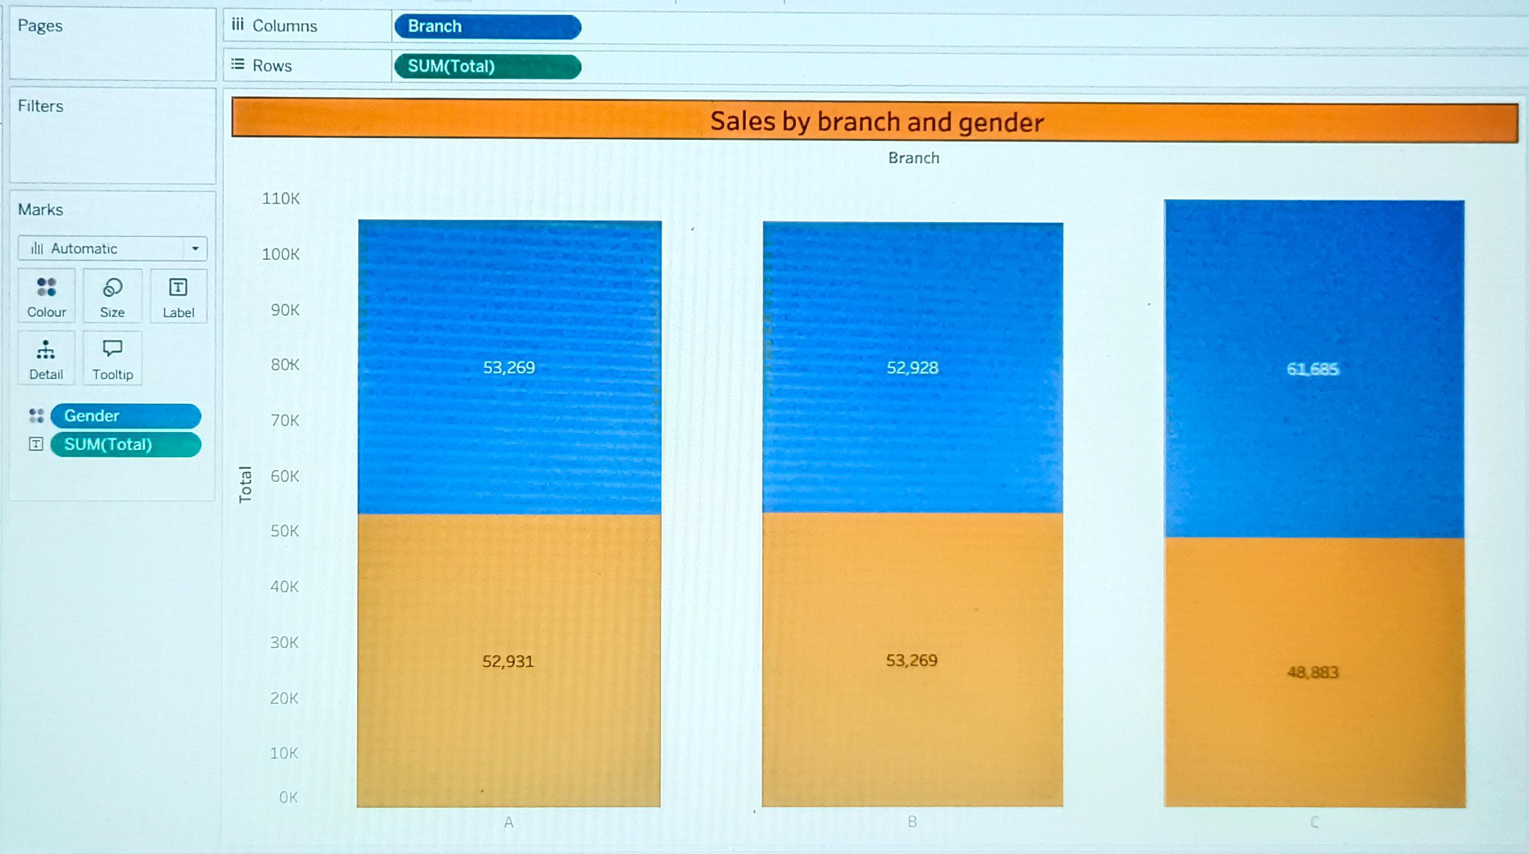

4. Line Chart

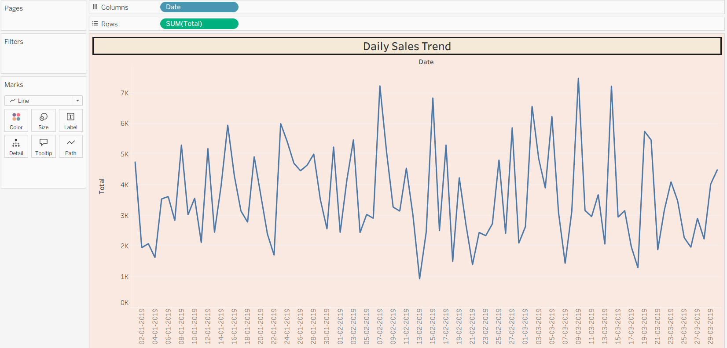

5. Bubble Chart

